**Ryuk**

**Initial Access**

* **Spearphishing**
  + https://www.advintel.io/post/front-door-into-bazarbackdoor-stealthy-cybercrime-weapon
  + Legitimate and widely used **SendGrid** email marketing platform
  + Decoy google preview page to trick the user into downloading
  + Malicious files are certificate signing to evading anti-virus
  + 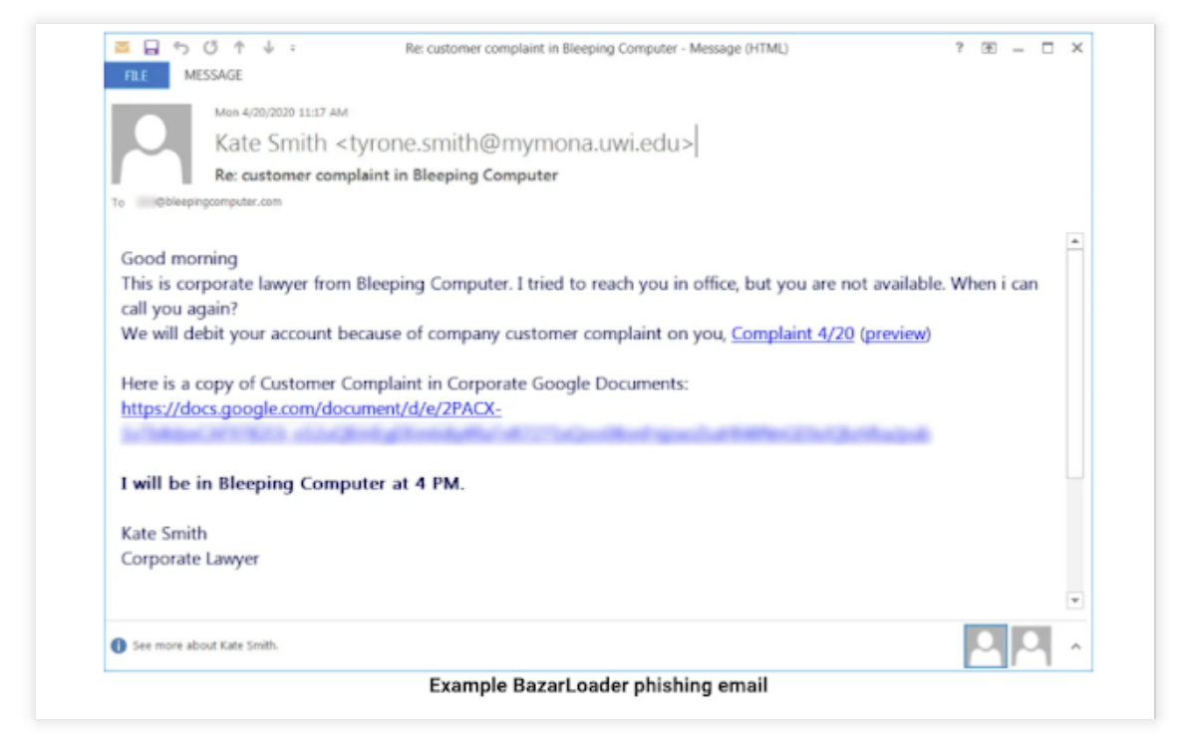Downloads encrypted BazarBackdoor
* **Bazar Execution**
  + <https://www.advintel.io/post/front-door-into-bazarbackdoor-stealthy-cybercrime-weapon>
  + **https://attack.mitre.org/software/S0534/**
  + Bazar relies on user execution of an executable to run.
  + This user was a Domain User and did not have any other permissions.
  + Injects malicious code into one of the following processes: cmd, explorer, and svchost
  + Scheduled task with the name such as "StartAd - Ad" is created, the loader writes itself into the Windows registry, and creates autorun entries
  + Download and execute the BazarBackdoor and Cobalt Strike beacons to further access once inside the targeted networks

**Privilege Escalation**

* **CVE-2020-1472**
  + https://resources.infosecinstitute.com/topic/zerologon-cve-2020-1472-technical-overview-and-walkthrough/
  + Attacker establishes a vulnerable Netlogon secure channel connection to a domain controller, using the Netlogon Remote Protocol
  + The attack is possible by taking advantage of the incorrect use of an AES mode of operating during the cryptographic process to spoof the identity of any computer account, including the DC itself, and thus setting an empty password for that account locally.
  + In order to exploit this vulnerability, attackers must be able to set up a TCP connection with the DC server from the internal network or even exploiting a webserver online, compromising it and breaking the barriers of a potential DMZ misconfigured (a scenario exploited in the wild by criminals and presented towards the end of the article).

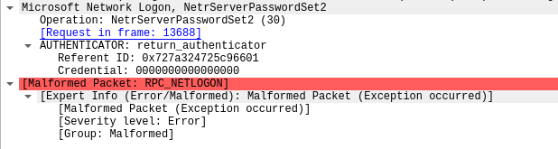

**Defense Evasion**

* **Signed Binary Proxy Execution: Rundll32**
  + <https://attack.mitre.org/techniques/T1218/011/>
  + Adversaries may abuse rundll32.exe to proxy execution of malicious code. Using rundll32.exe, vice executing directly (i.e. Shared Modules), may avoid triggering security tools that may not monitor execution of the rundll32.exe process because of allowlists or false positives from normal operations. Rundll32.exe is commonly associated with executing DLL payloads.
  + CVE-2020-14 On the first domain controller that the treat actors connected to after their initial connection, they dropped a DLL and executed it via rundll32.
  + Dropped via RDP and executed via rundll32 on the second domain controller.
  + Shortly after, the DLL was called again via regsrv32.
  + Then a 2nd DLL was dropped and executed in a similar manner on the 2nd DC.

**Discovery**

* **Signed Binary Proxy Execution: Rund**

**Lateral Movement**

* **Signed Binary Proxy Execution: Rund**

**Command and Control**

* **Signed Binary Proxy Execution: Rund**

**Impact**

* **Compromise entire network**
  + https://www.crowdstrike.com/blog/big-game-hunting-with-ryuk-another-lucrative-targeted-ransomware/
  + Starting around 4.5 hours after the initial Bazar malware was executed, the Ryuk threat actors acted on their final objectives and initiated RDP connections from the domain controller previously exploited, to the rest of the environment. This time they initiated the ransomware first on the secondary domain controller (their 1st pivot) and transferred the Ryuk executable over the RDP connection.
  + Ryuk is a Ransomware — a type of malware that encrypts files of the victim and restores access in exchange for a ransom payment
  + Based on observed transactions to known Ryuk BTC addresses, the ransom demand varies significantly. This suggests that WIZARD SPIDER (like INDRIK SPIDER with BitPaymer) calculates the ransom amount based on the size and value of the victim organization. To date, the lowest observed ransom was for 1.7 BTC and the highest was for 99 BTC. With 52 known transactions spread across 37 BTC addresses (as of this writing), WIZARD SPIDER has made 705.80 BTC, which has a current value of $3.7 million (USD). With the recent decline in BTC to USD value, it is likely GRIM SPIDER has netted more. The tables in the Appendix include a set of known Ryuk BTC addresses extracted from Ryuk binaries, which are believed to be only a subset of the Ryuk BTC addresses.

